|  |  |
| --- | --- |
| Name | Naman Choudhary |
| SRN | PES2UG20CS209 |
| Section | D |

**ARP Cache Poisoning Attack Lab**

Lab 3

Task 1: ARP Cache Poisoning

Task 1.A: Using ARP request

Without Ether:

Command:

On Host A and B

# arp

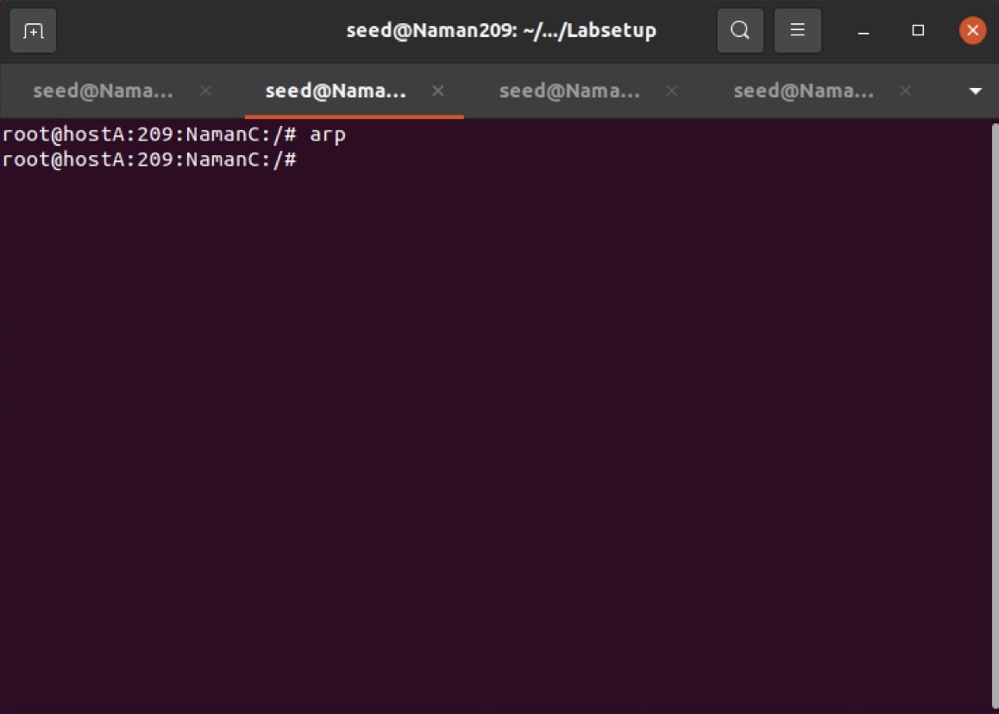

On Host A and B

# tcpdump -i eth0 -n

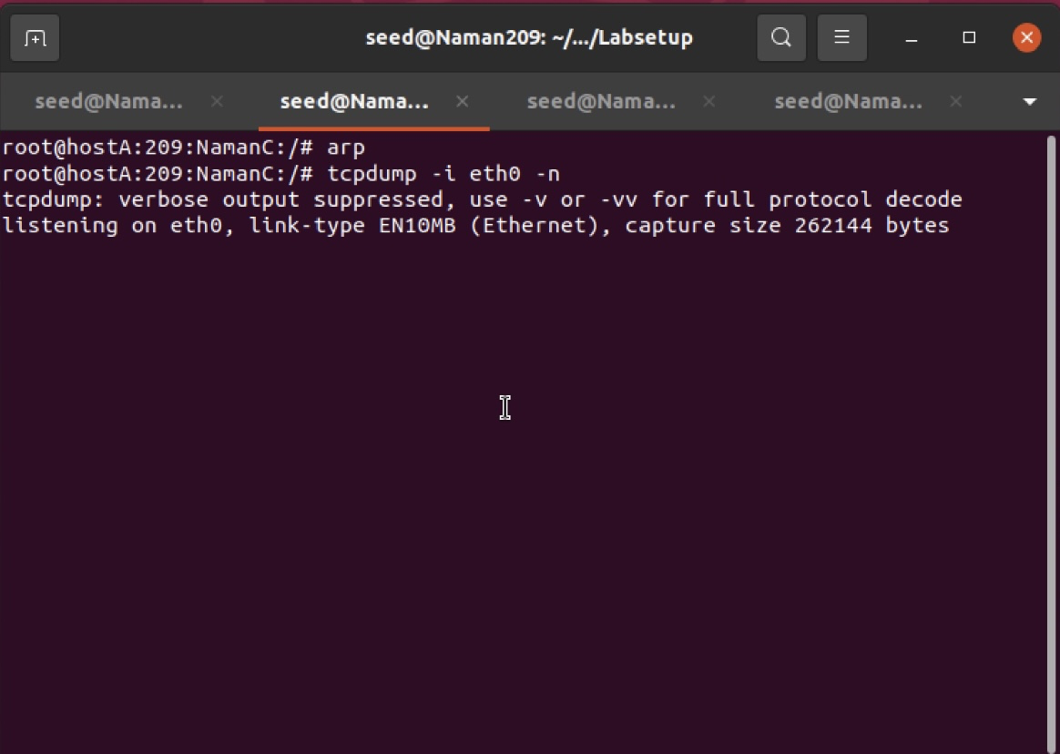

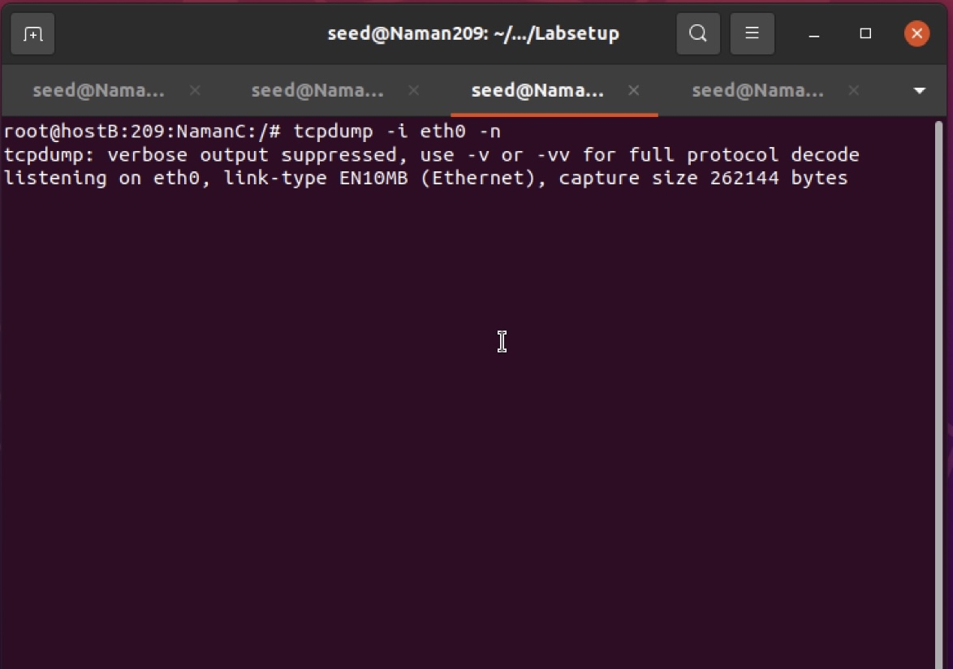

On Attacker M

# python3 task1A.py

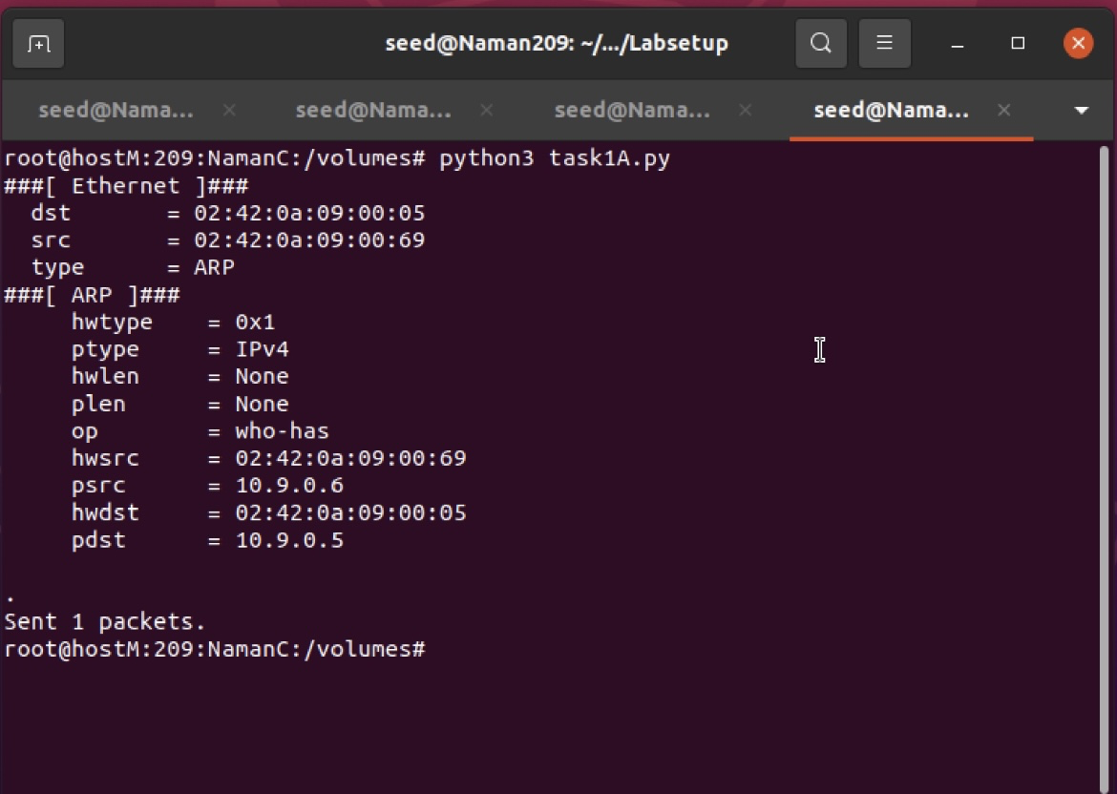

After the attack:

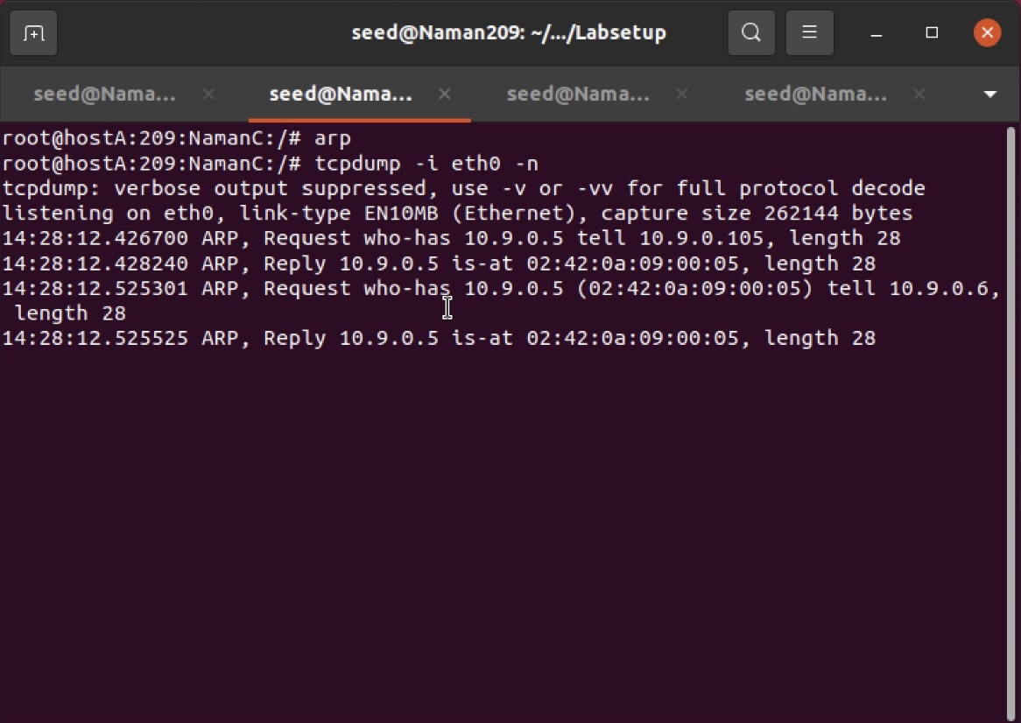

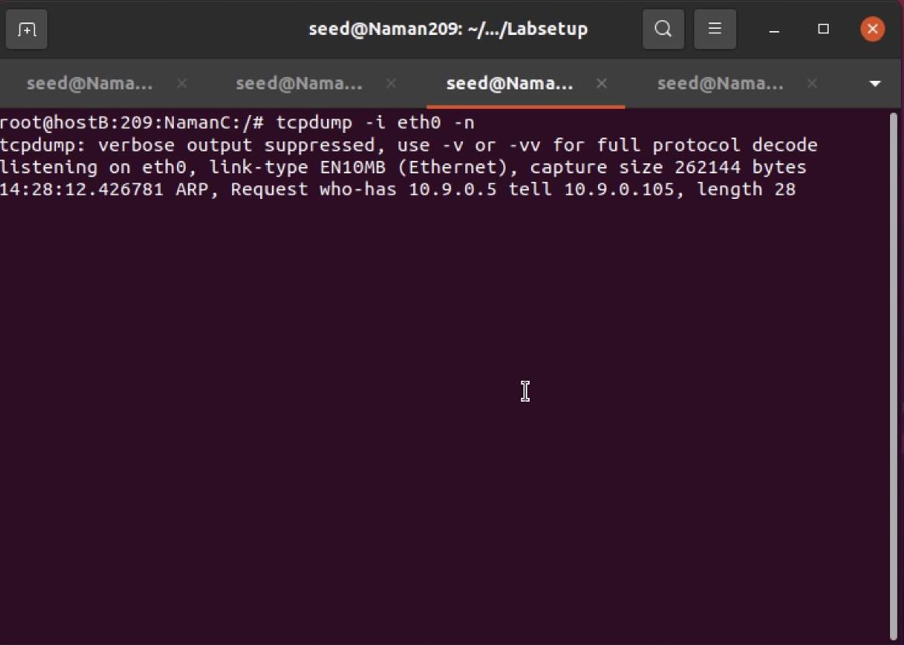

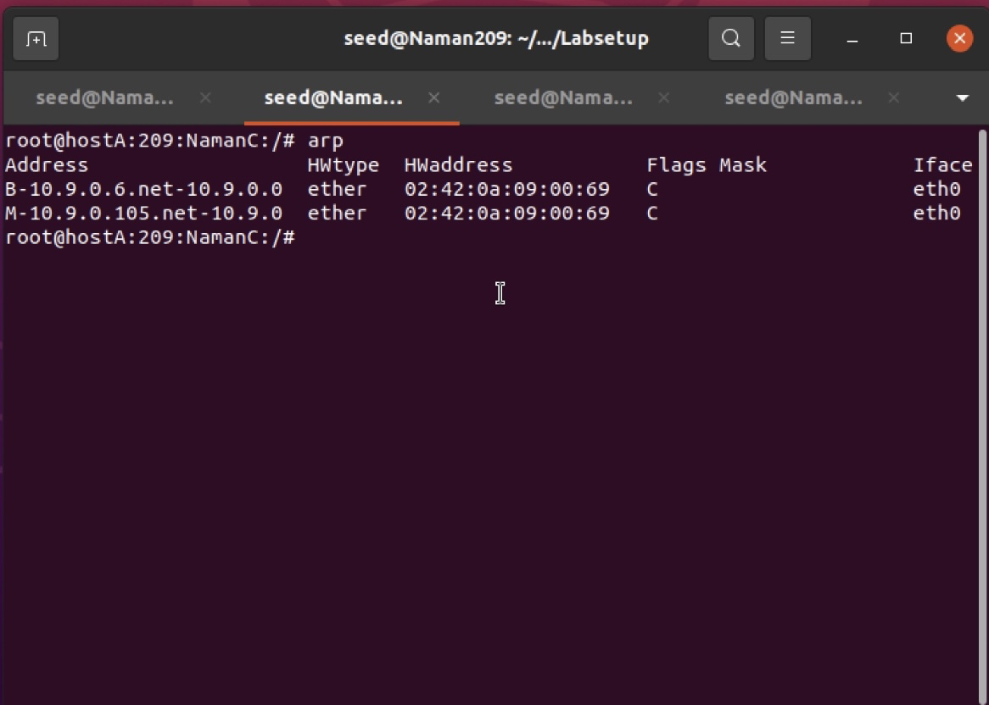

With Ether:

On Host A and B

# arp

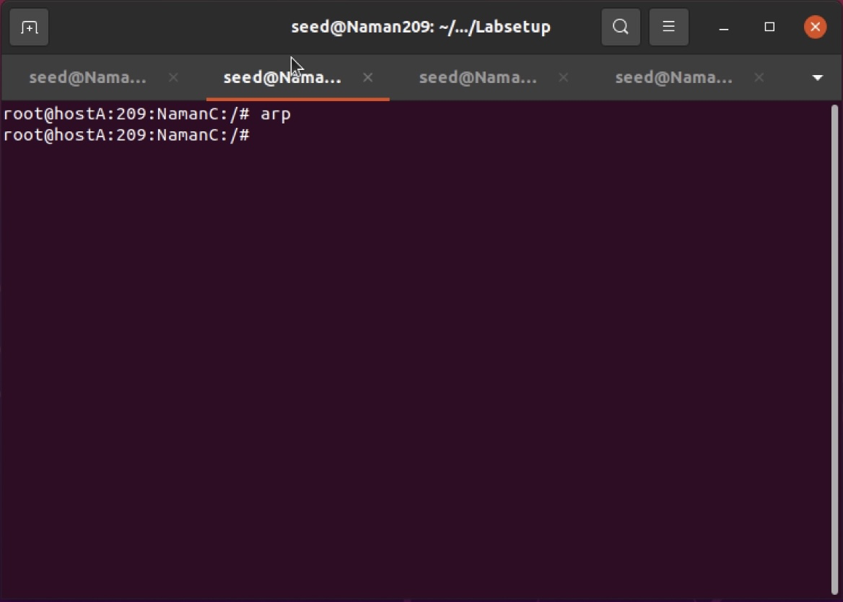

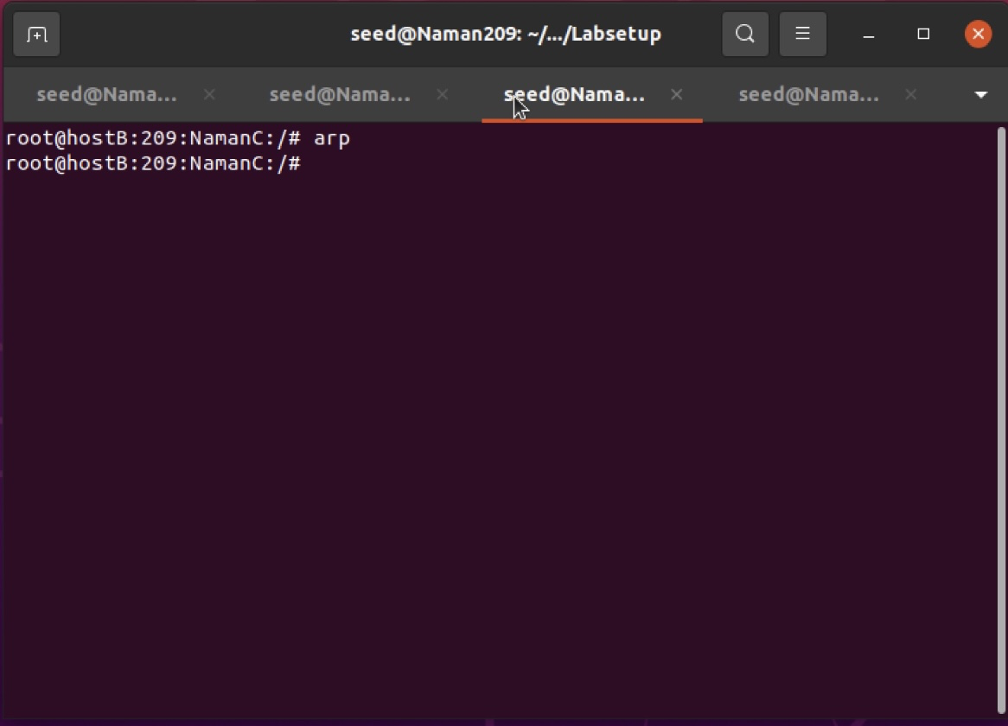

On Host A and B

# tcpdump -i eth0 -n

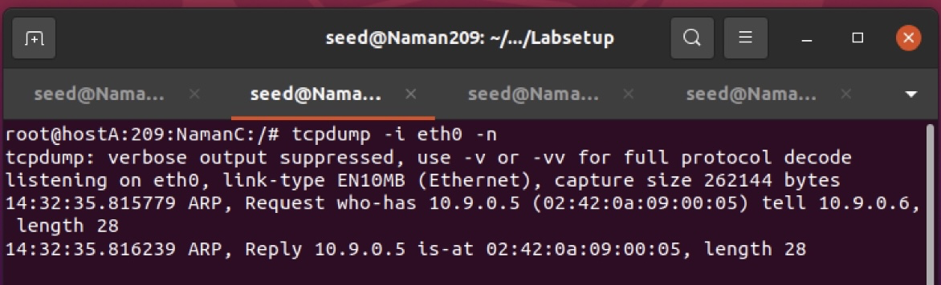

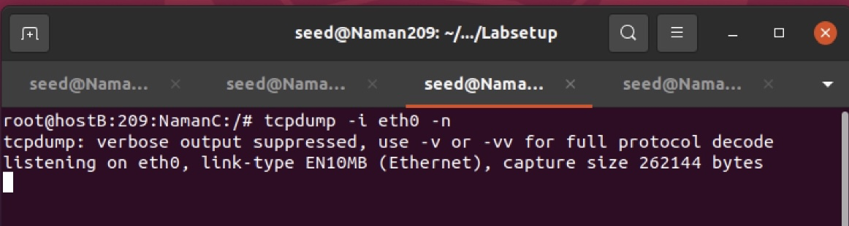

On Attacker M

# python3 task11A.py

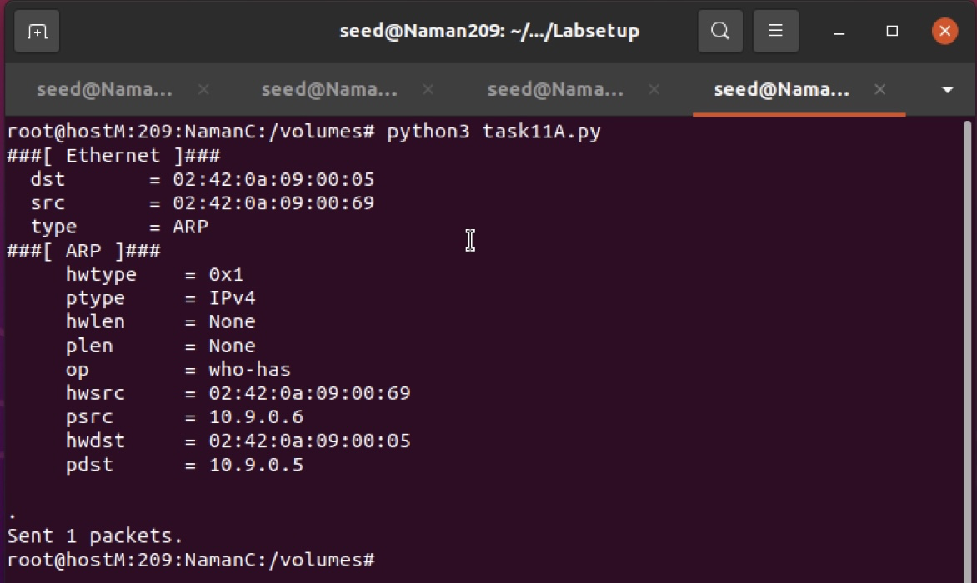

After the attack: 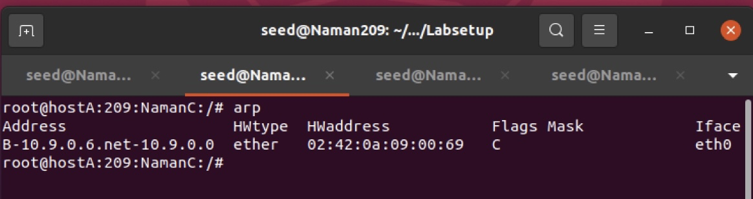

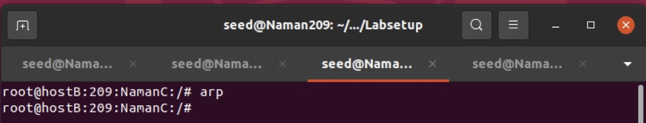

Questions:

1. What does the ‘op’ in the screenshot of the attacker machine signify? What is its default value?
   * ‘op’ in ARP is Operation Code and the default value of op is set 1(ARP Request)
2. What was the difference between the ARP cache results in the above 2 approaches? Why did you observe this difference?
   * Difference was in the header fields between the 2 approaches. The header was not manually set in approach 1, resulting in additional entry of attacker’s IP(which should not happen in an actual attack) too.
   * In approach 2, header was set manually to manipulate host A’s cache resulting in modified A’s ARP table

Task 1.B: Using ARP Reply

For Scenario 1

On Attacker M

# python3 task11A.py

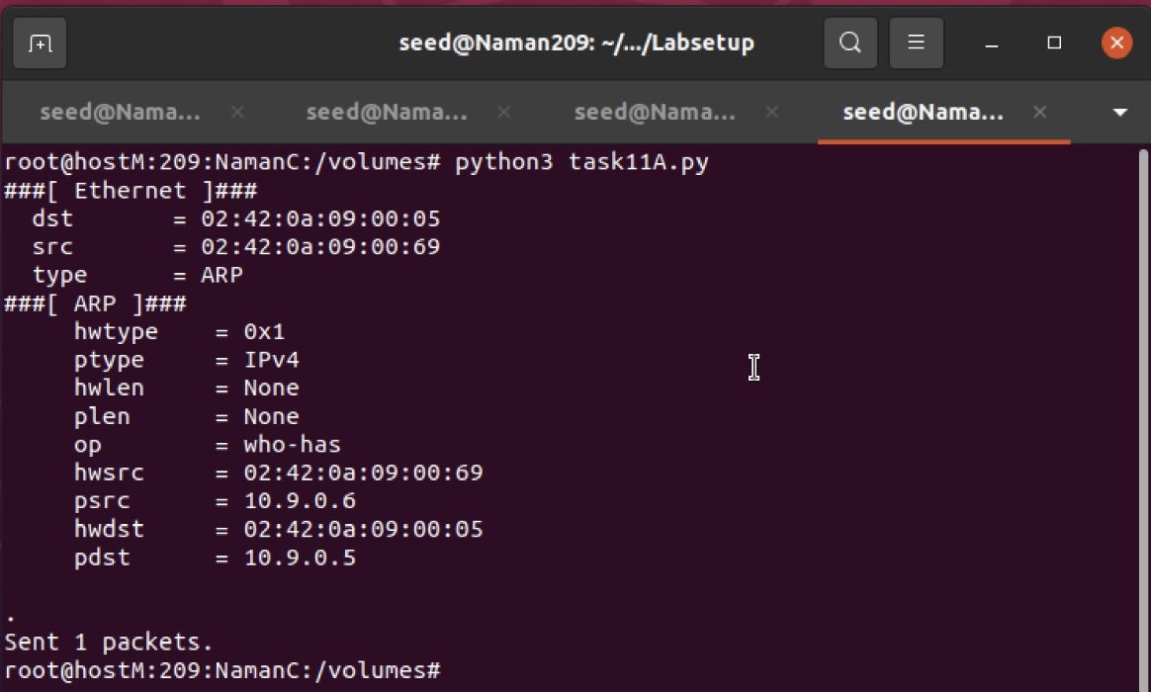

On Host A

# tcpdump -i eth0 -n

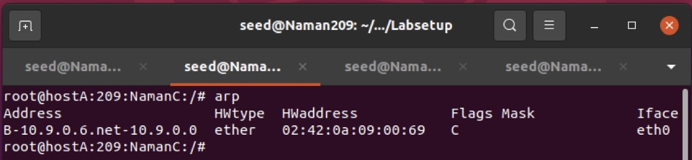

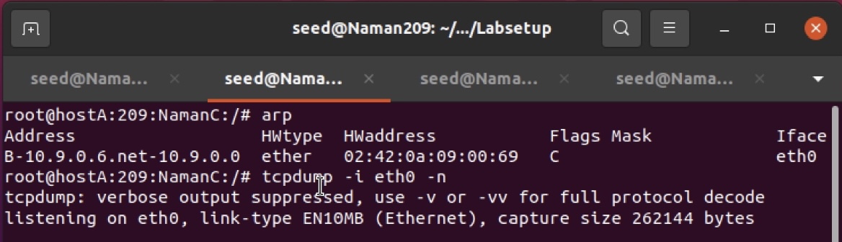

On Attacker M

# python3 task1B.py

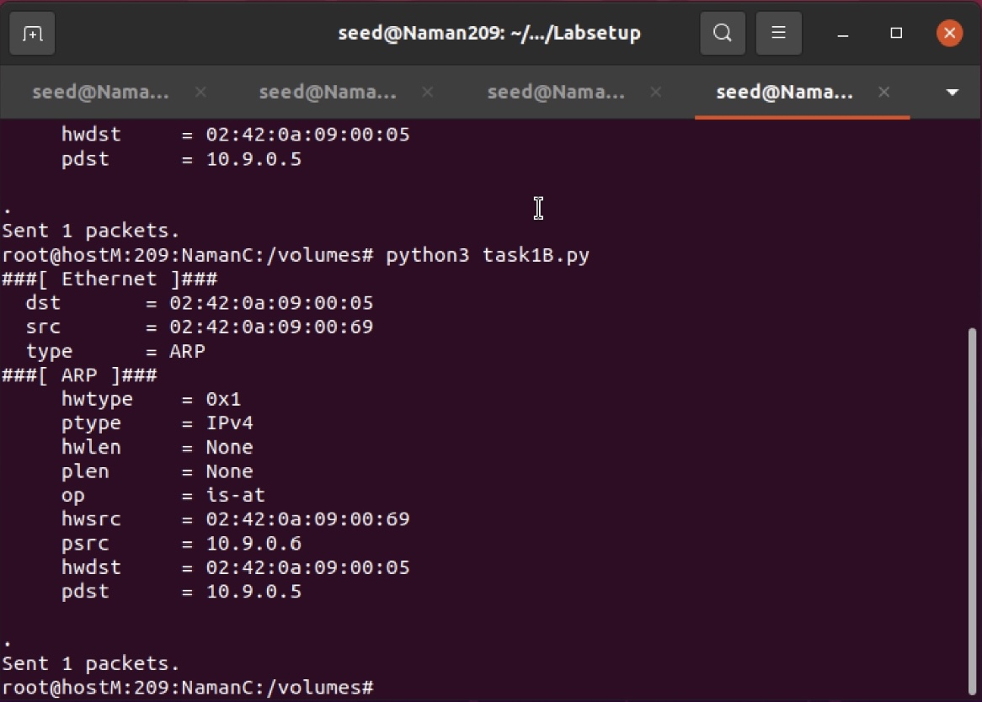

After the attack:

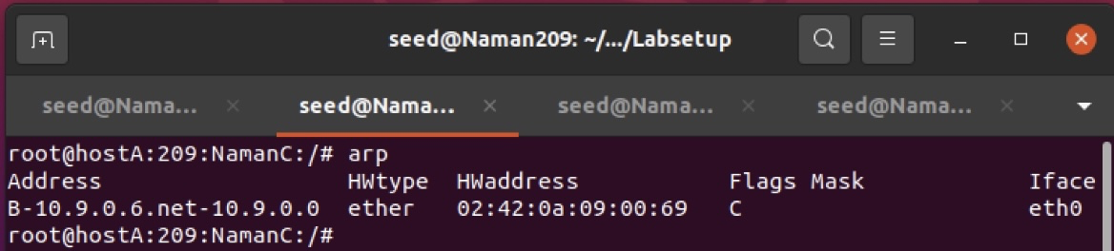

For Scenario 2

On Host A

# tcpdump -i eth0 -n

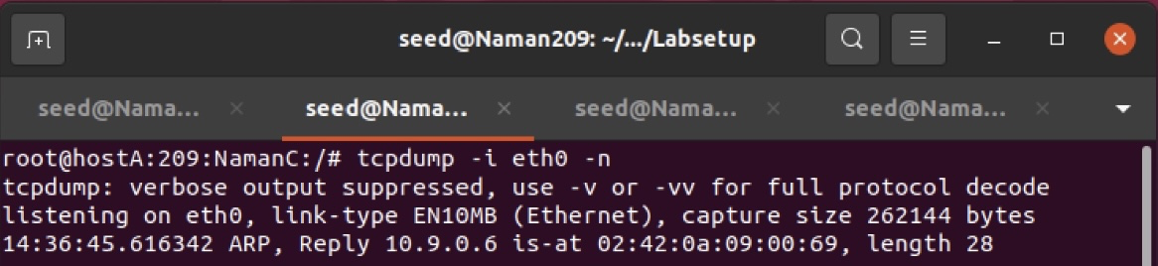

On Attacker M

# python3 task1B.py

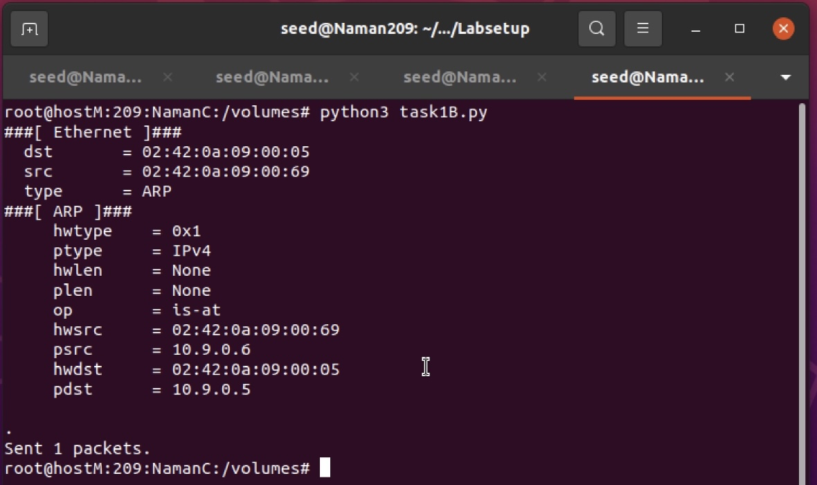

Question:  
1. What does op=2 mean?

* + ‘op’=2 refers to ARP Reply

Task 1.C: Using ARP Gratuitous Message

For Scenario 1

On Attacker M

# python3 task1A.py

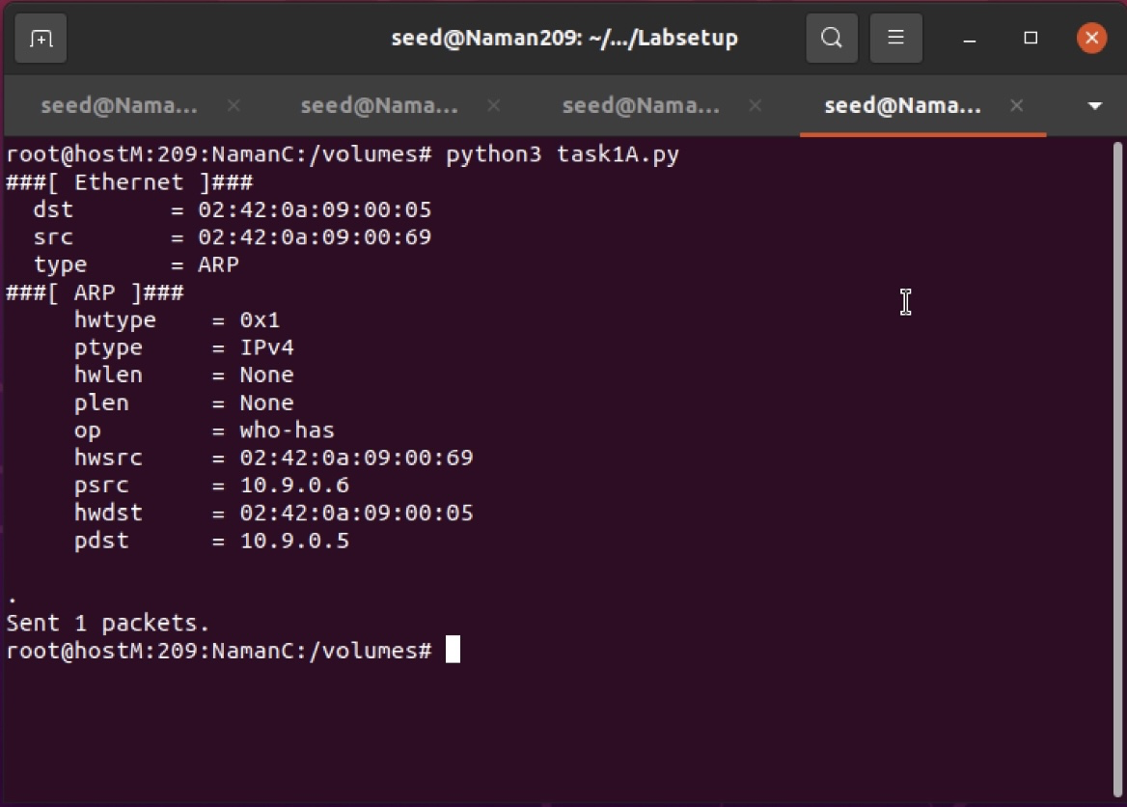

ARP on Host A:

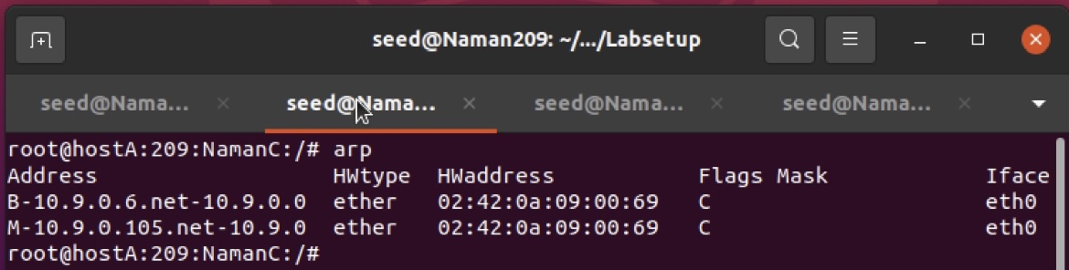

On Host A and Host B

# tcpdump -i eth0 -n

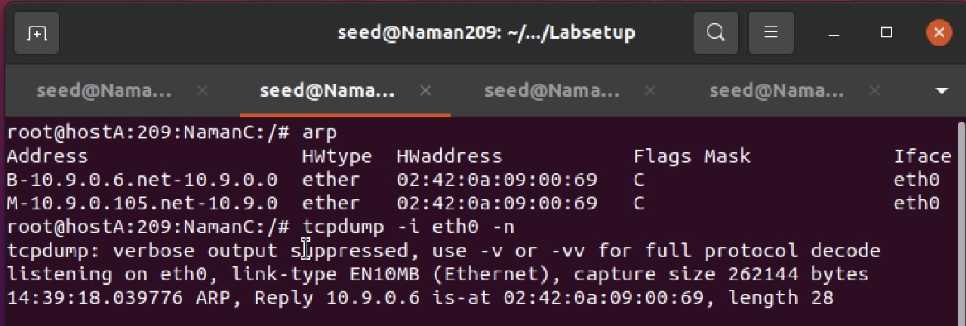

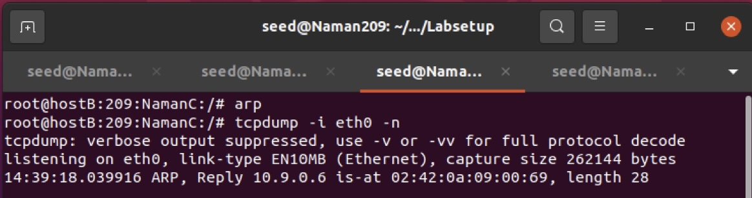

Attacker M

# python3 task1C.py

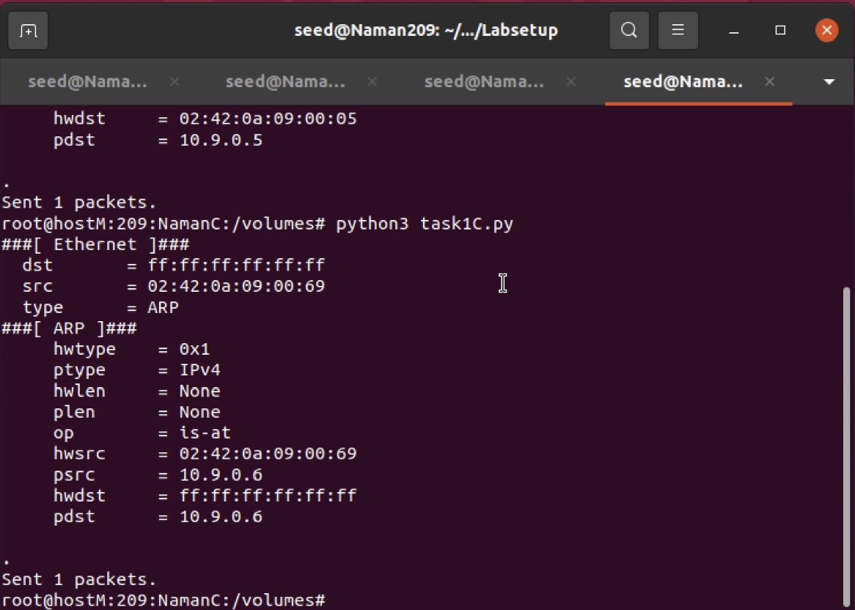

After the attack:

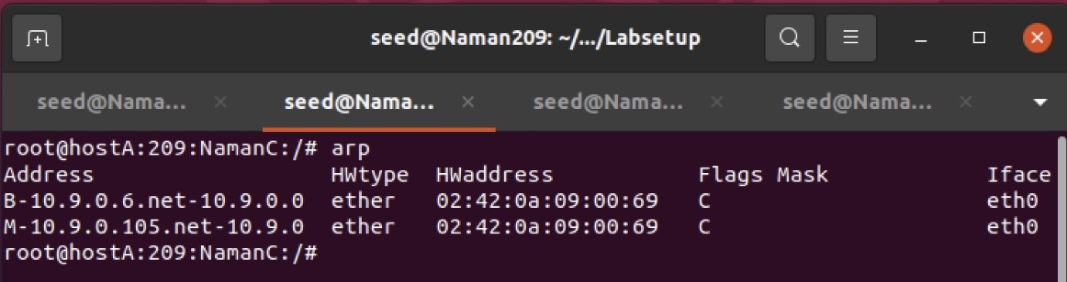

For Scenario 2

On Host A and B

# tcpdump -i eth0 -n

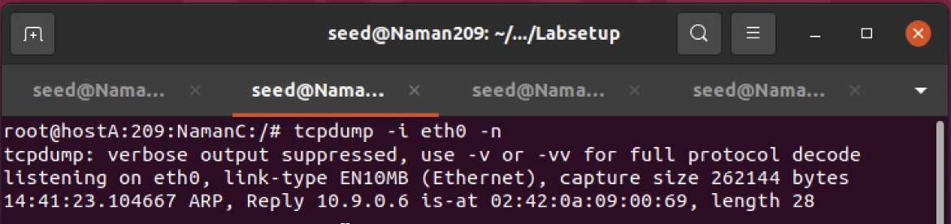

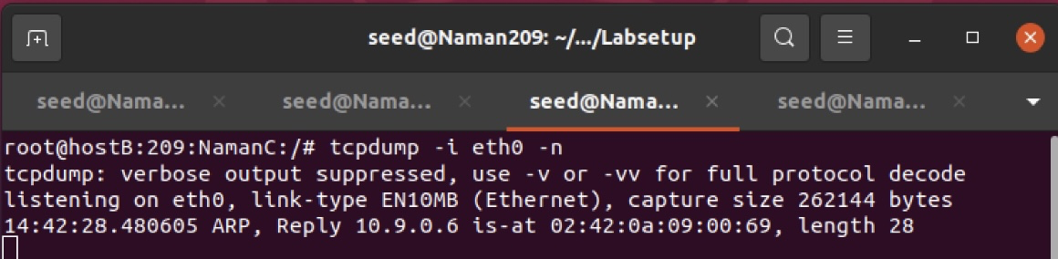

On Attacker M

# python3 task1C.py

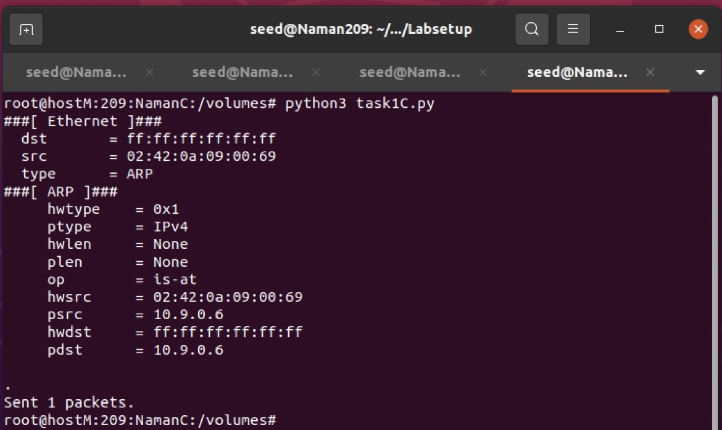

After the attack:

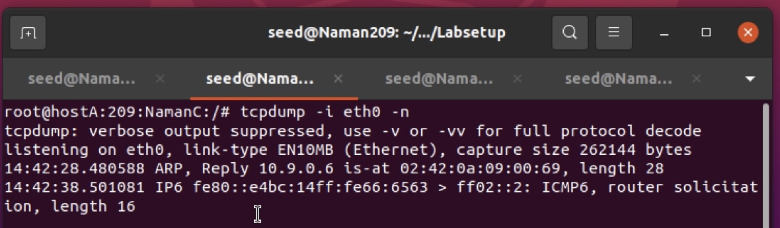

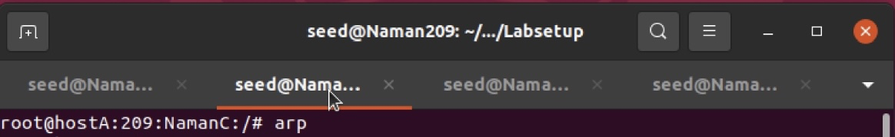

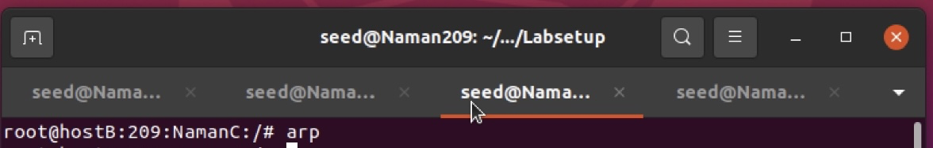

Questions:  
1. Why does VM B’s ARP cache remain unchanged in this approach even though the packet was broadcasted on the network?

* + Host B’s ARP remains unchanged since the IP of sender and IP of B are same, and ARP has only entries of IPs which donot belong to the host itself

Task 2: MITM Attack on Telnet using ARP Cache Poisoning

Command:

# python3 task11A.py

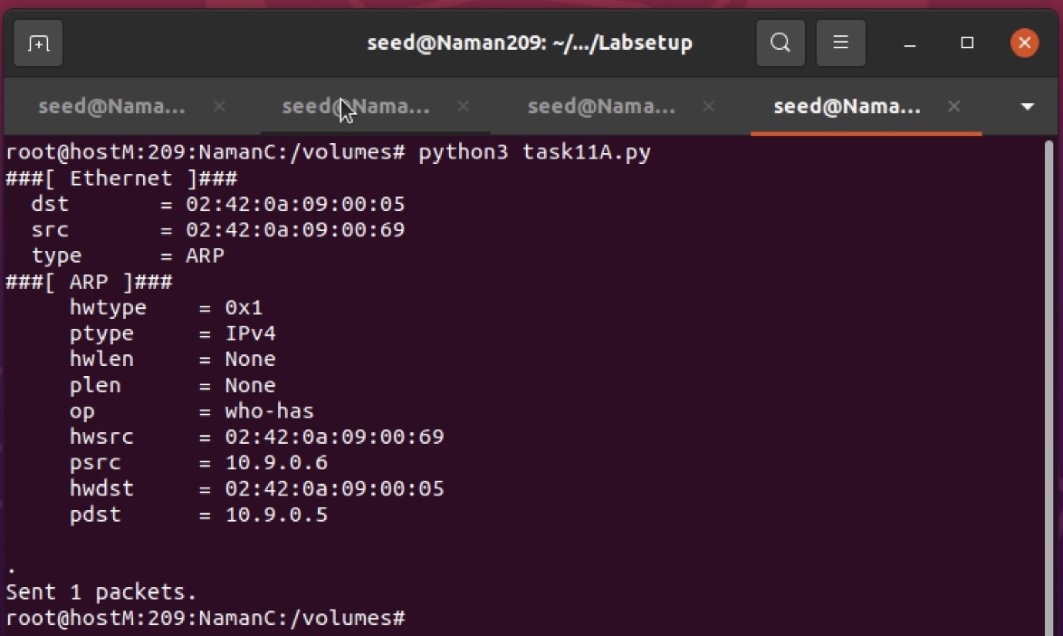

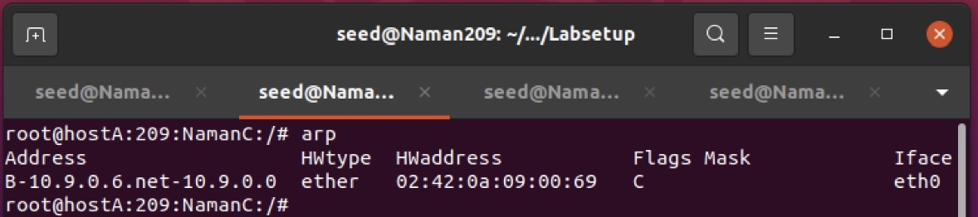

Command:

# python3 task2.py

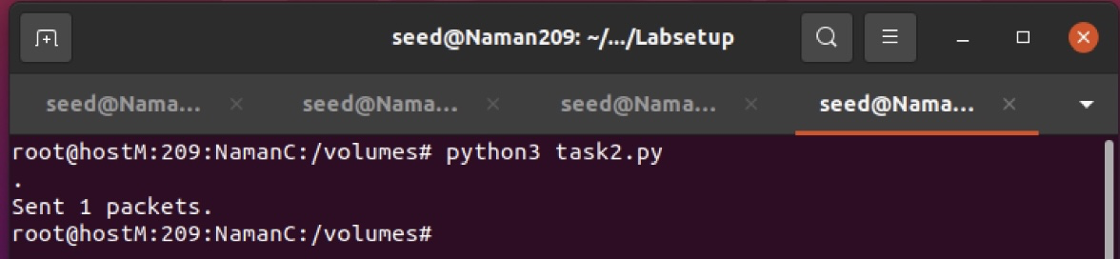

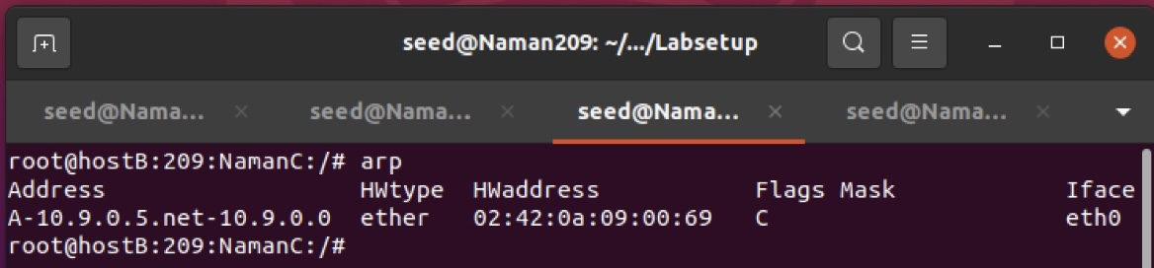

On Attacker M

# python3 task11A.py # python3 task2.py

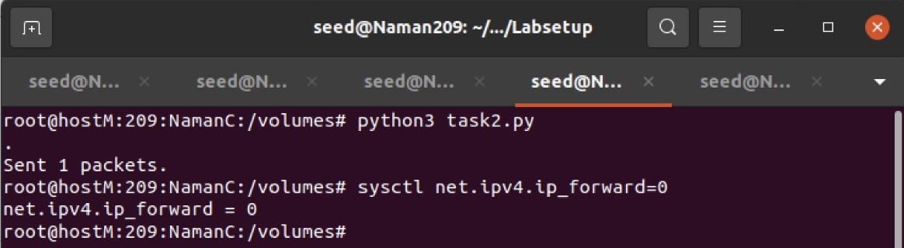

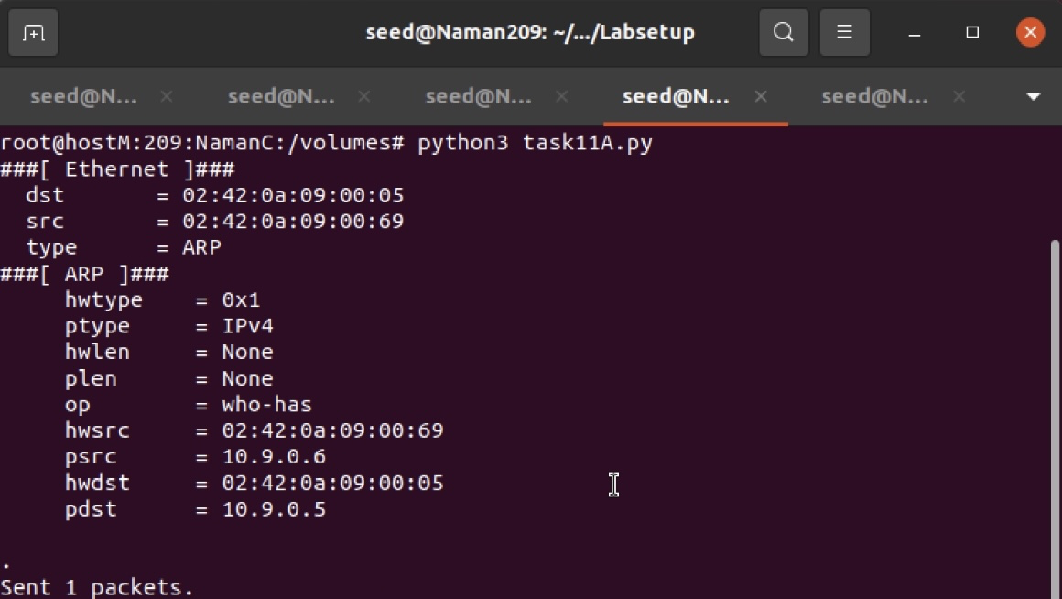

Wireshark output:

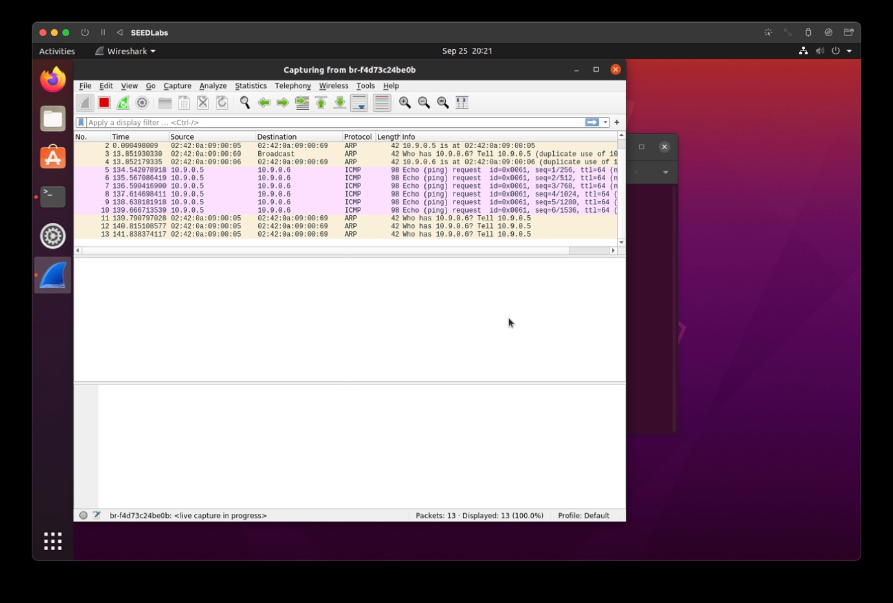 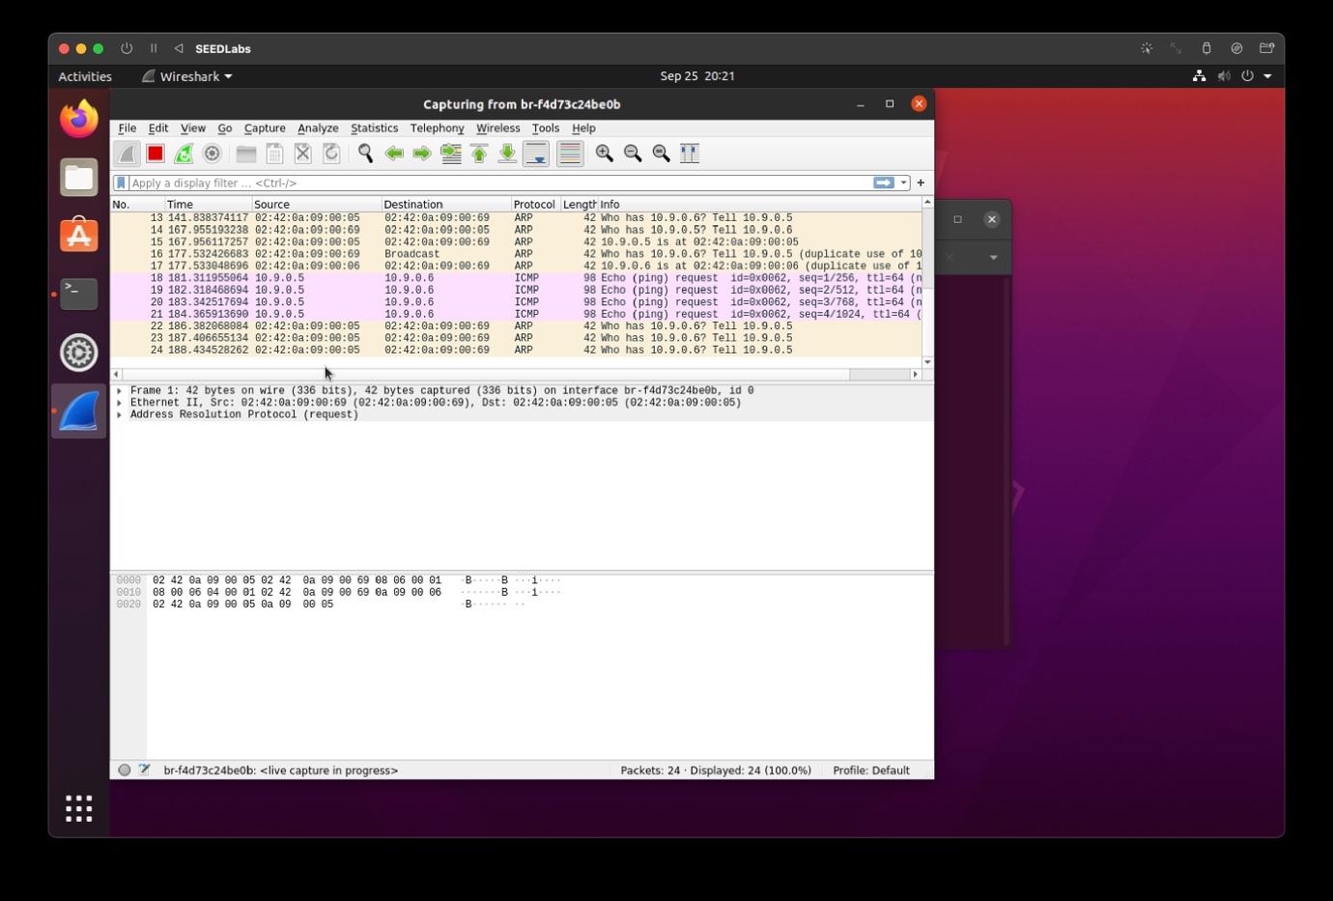

On Host A

# ping 10.9.0.6

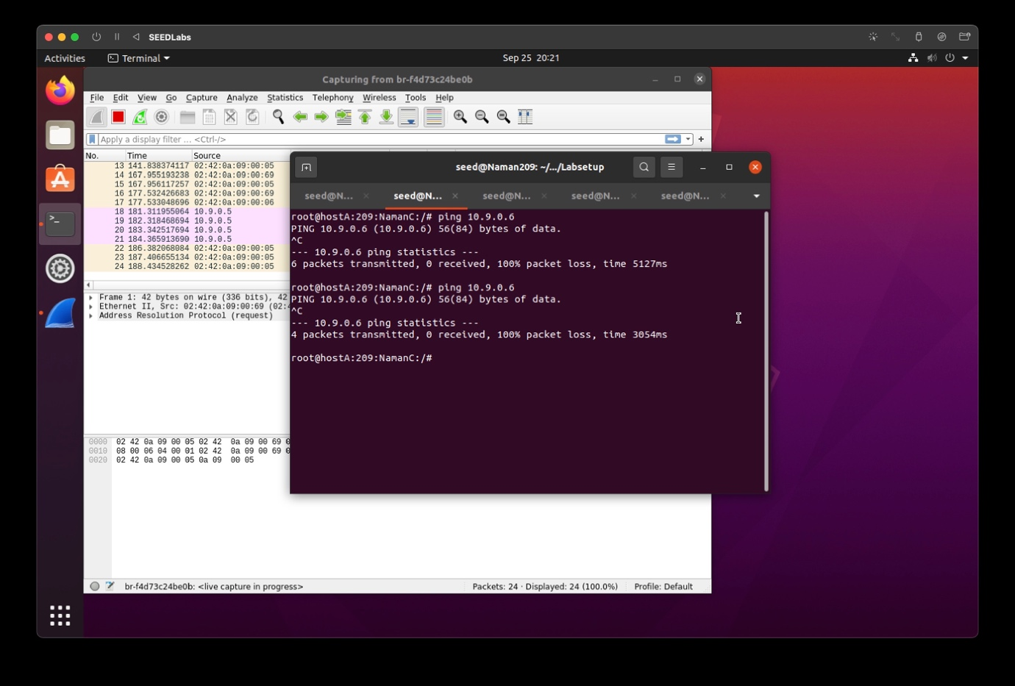

Pinging not successful , execute task 11A.py and task2.py

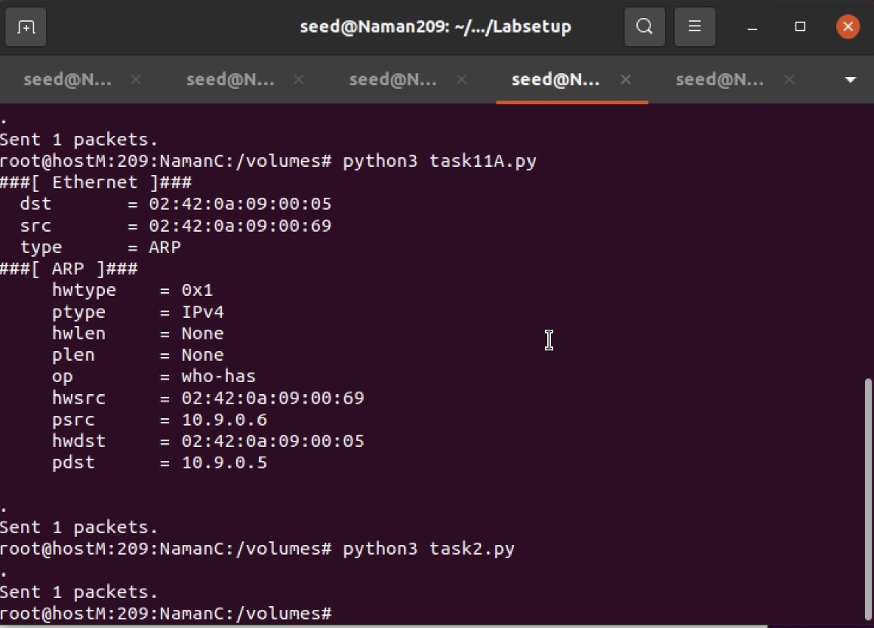

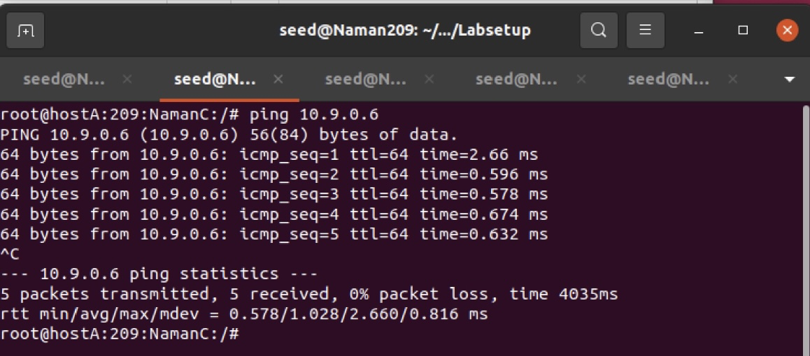

Pinging now successful

Question:

1. What do you observe? Explain

* + Initially, the pinging was not successful, because the IP address in attack M was not matching and discards the packets, but after executing the 2 python codes, the pinging started to happen.

Wireshark Output:

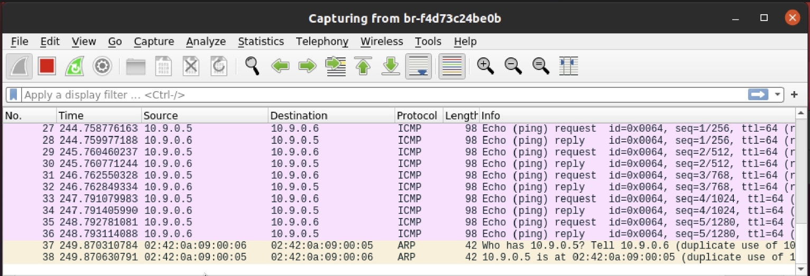

Question  
1. Compare the results between the above two steps.

* + After turning on IP Forwarding ICMP redirection from Attacker M to Host A takes place, which forwards the packet to B, and at the same time, M sends a ICMP redirect message to A

On Host A Command:

# telnet 10.9.0.6

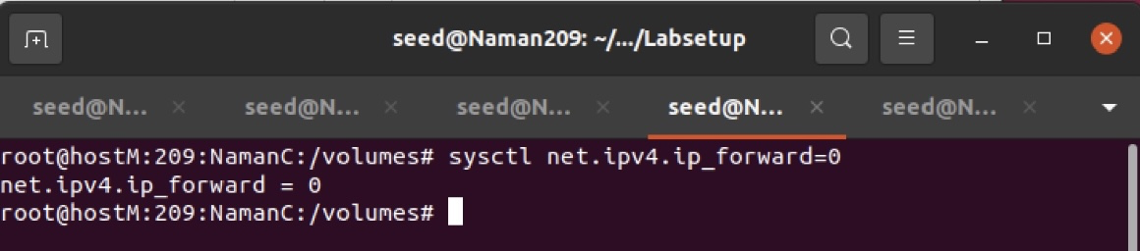

Back On Host M Command:

# sysctl net.ipv4.ip_forward=0

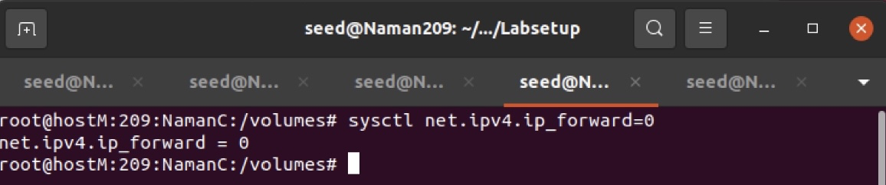

On Host A Command:

# telnet 10.9.0.6

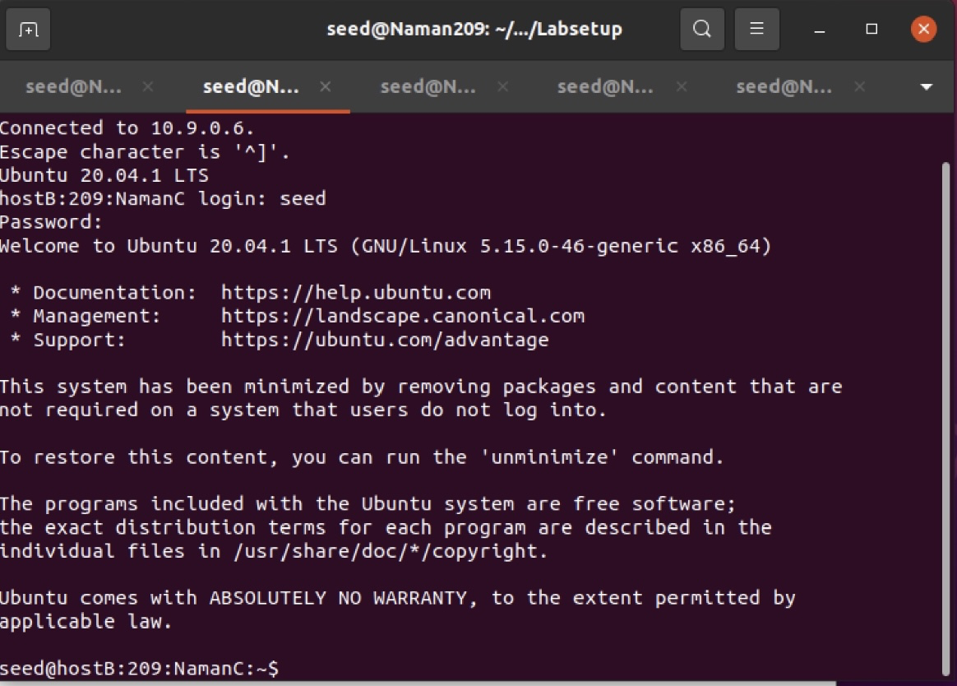

Wireshark Output:

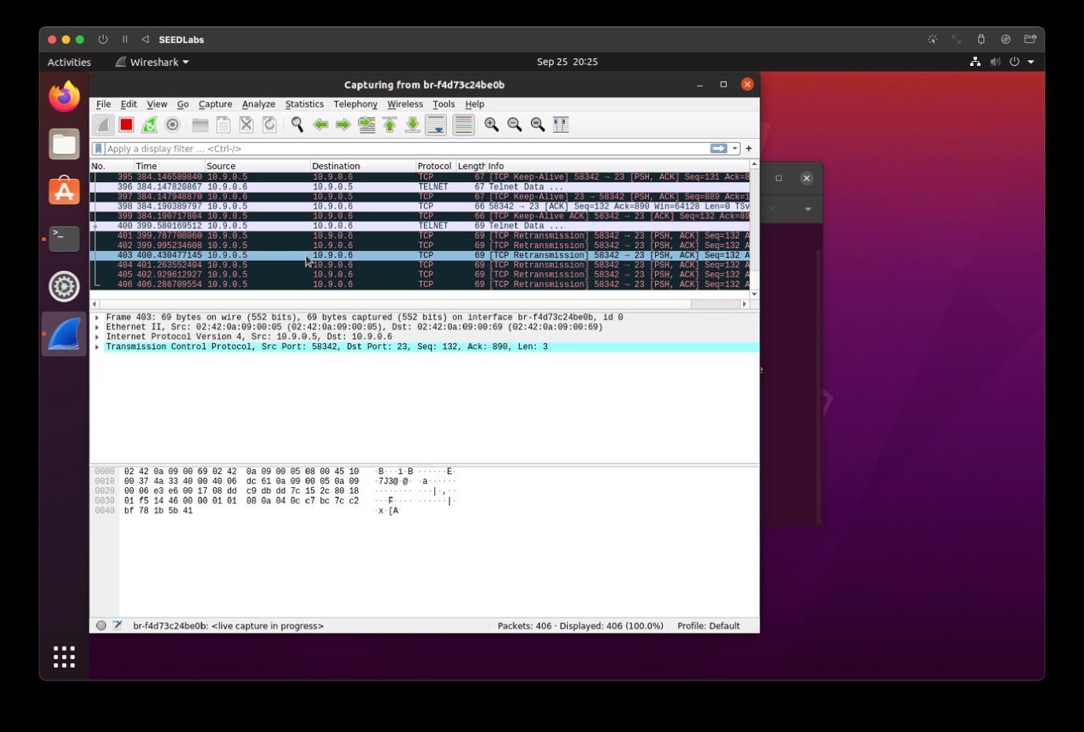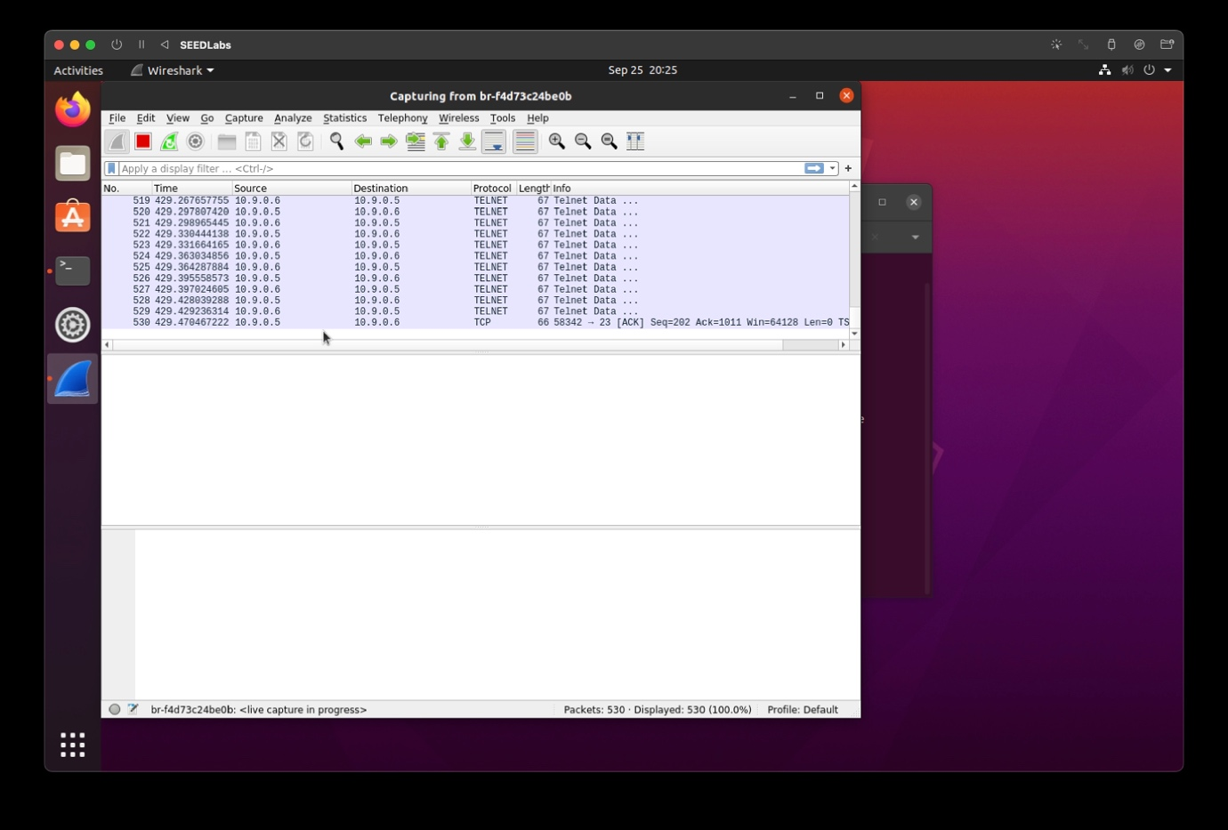

Command:

# python3 task11A.py

# python3 task2.py

# python3 mitm.py

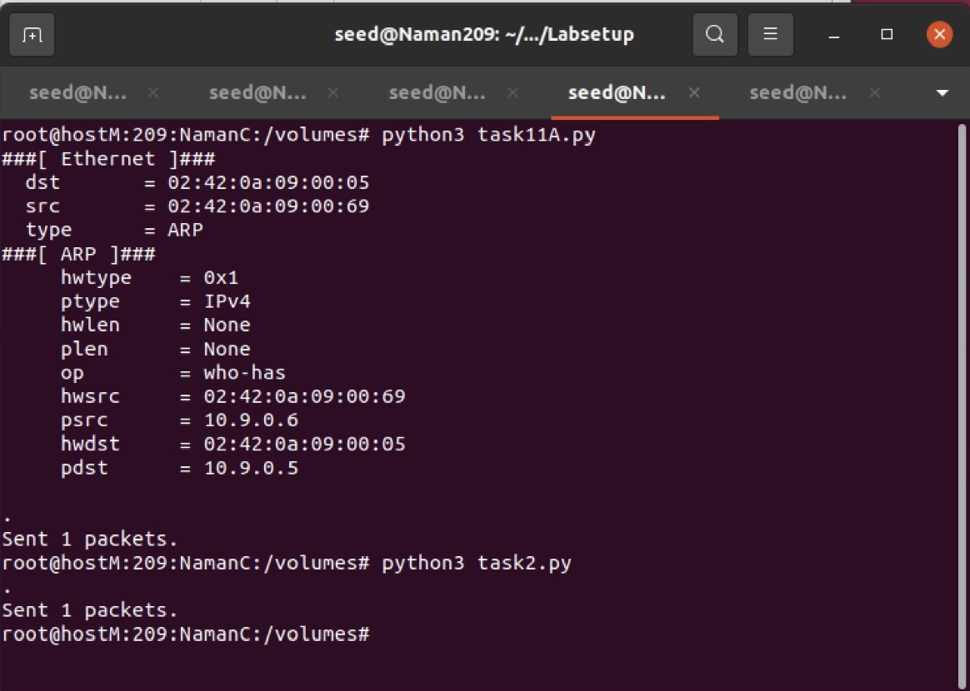

Attack Output:

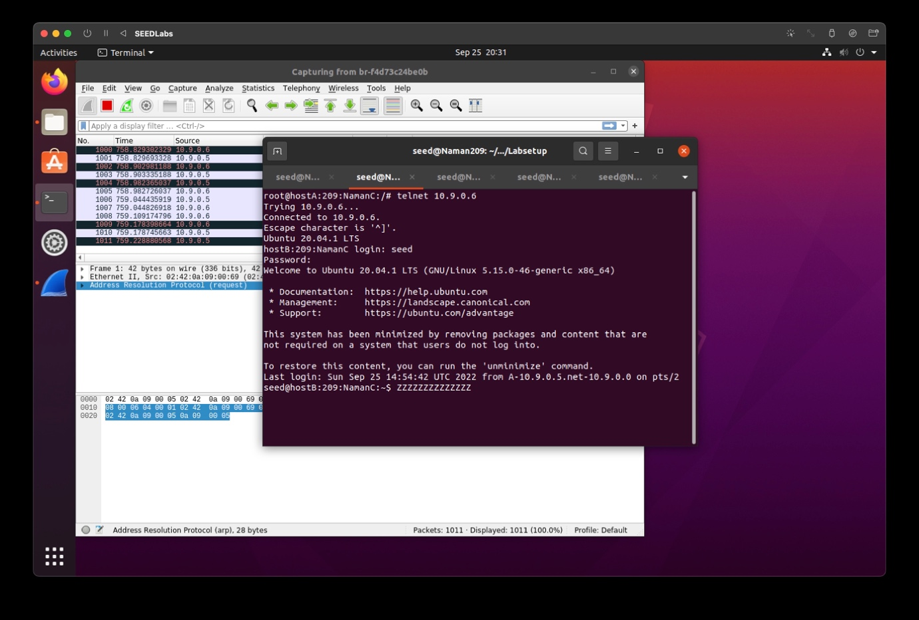

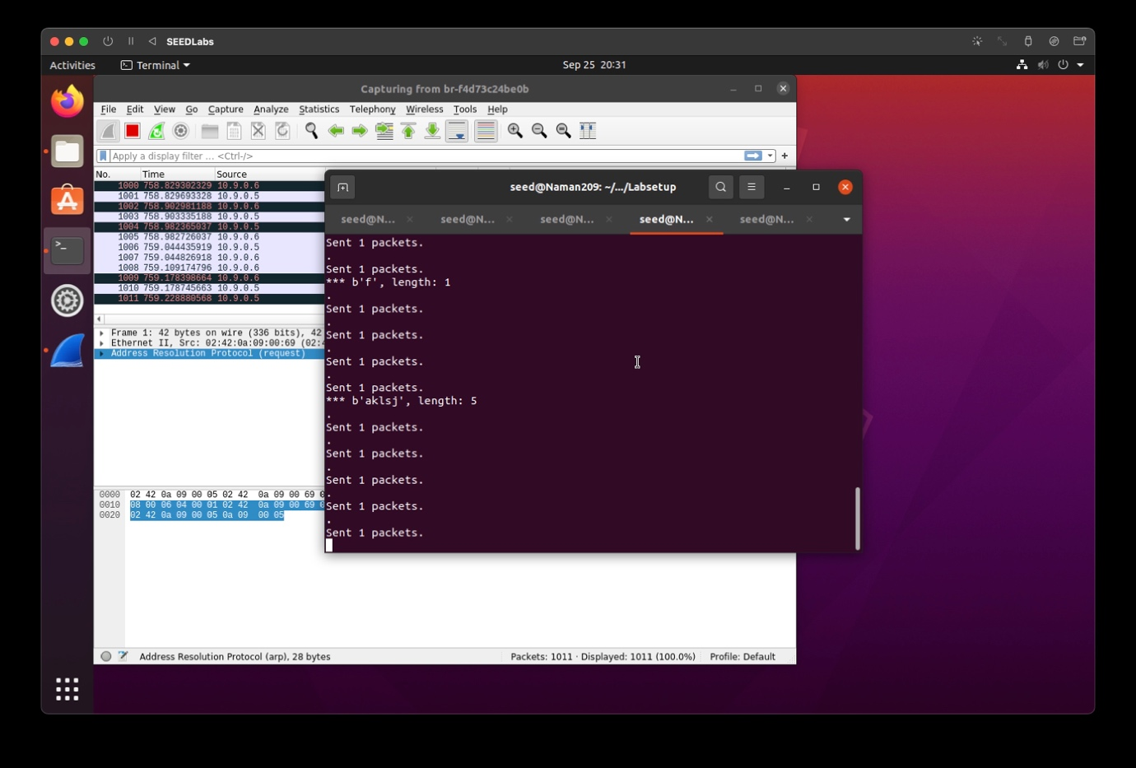

Task 3: MITM Attack on Netcat using ARP Cache Poisoning

OnAttackerM -

# python3 task11A.py

# python3 task2.py

# sysctl net.ipv4.ip_forward=1

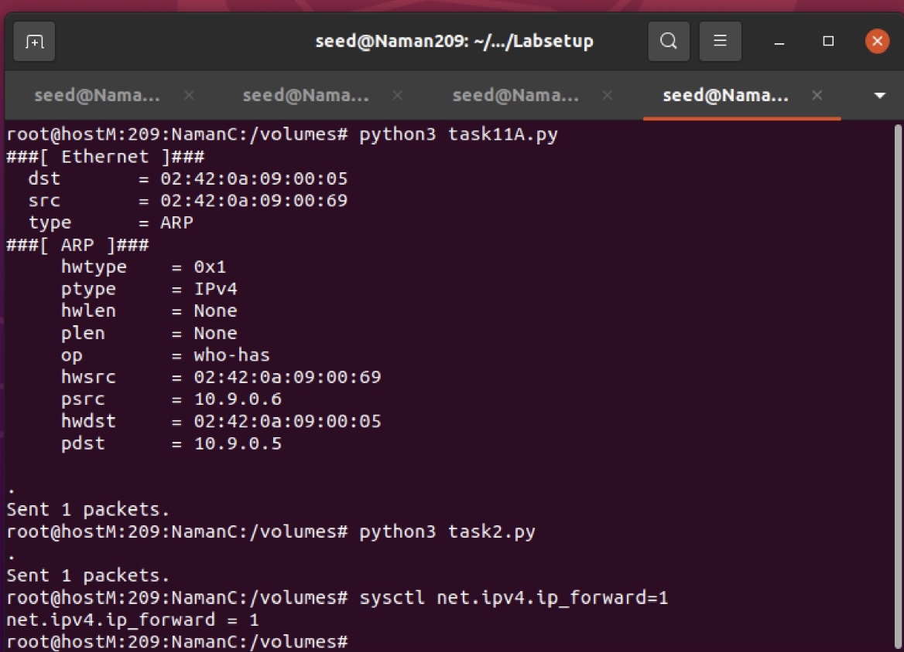

On Attacker M -

# python3 task11A.py

# python3 task2.py

# sysctl net.ipv4.ip_forward=0 # python3 mitm1.py

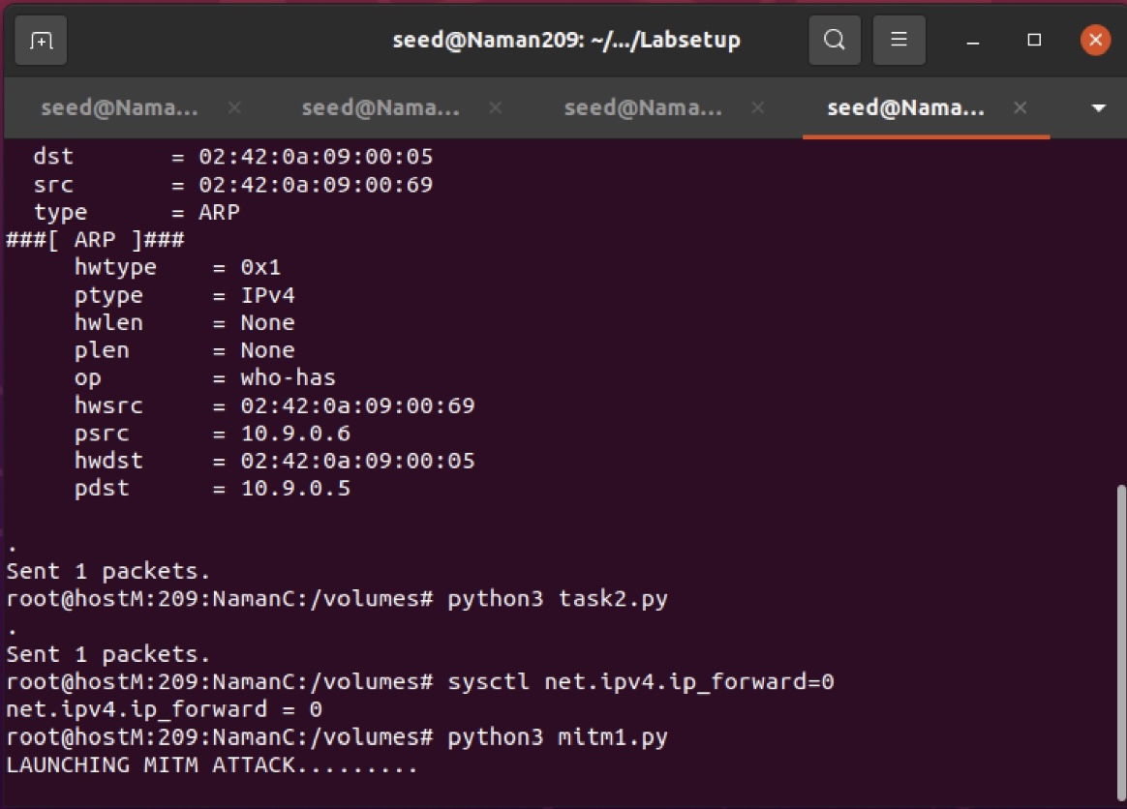

After the attack output:

On Host A -

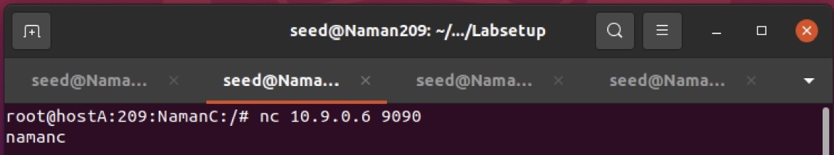

On Host B -

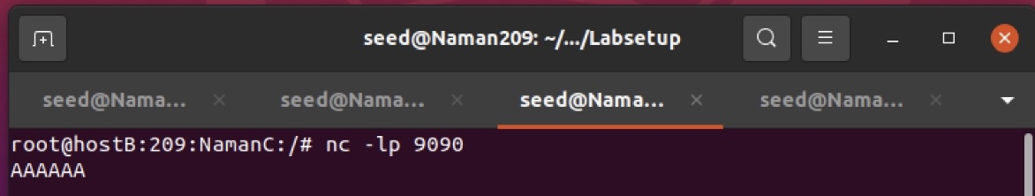

We observe that our 6 letter input ‘namanc’ changes to ‘AAAAAA’ instantly on host B when the attack in launched.